Printing Your Class QR Poster – Feb 2019

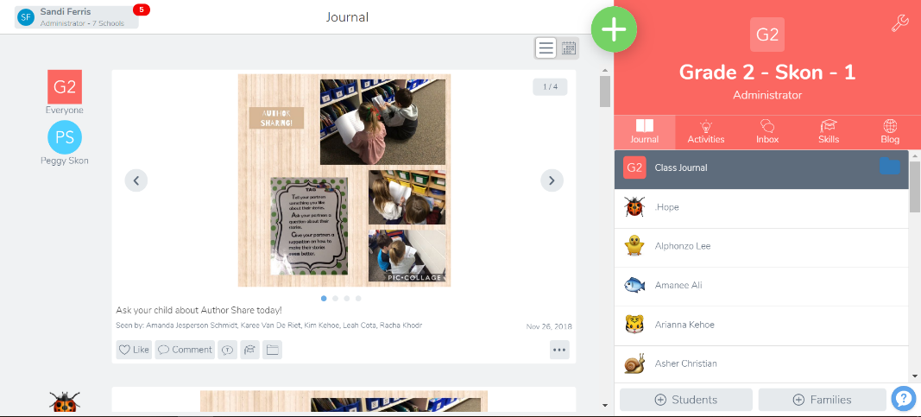
Log in to your teacher account on a computer so you can print.

Click on the “+ Students” button.

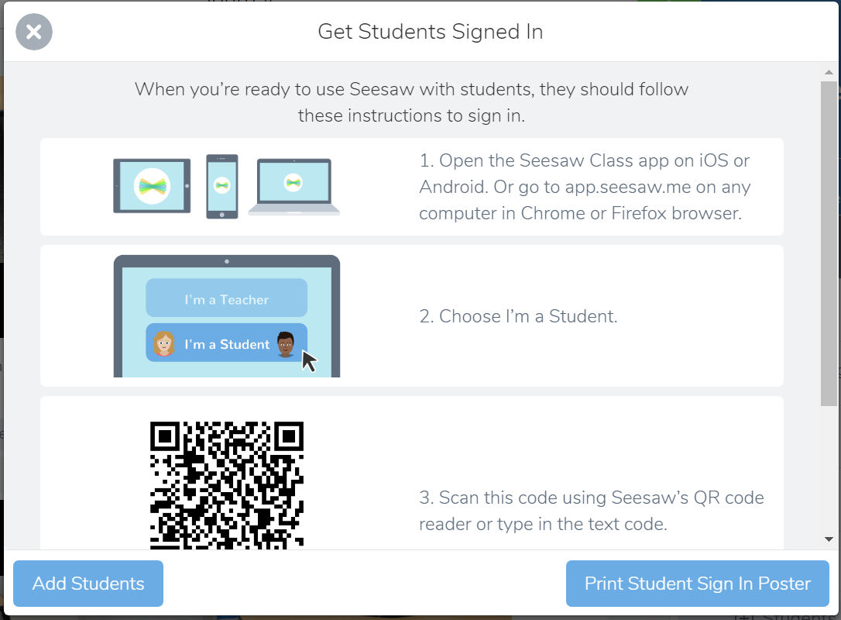
A window with the directions on how to get a student signed in will pop up.
Click the “Print Student Sign in Poster”
Print the QR Code poster (page 3).
This poster is for you classroom only. DO NOT SEND IT HOME OR POST IT ANYWHERE ON SOCIAL MEDIA.

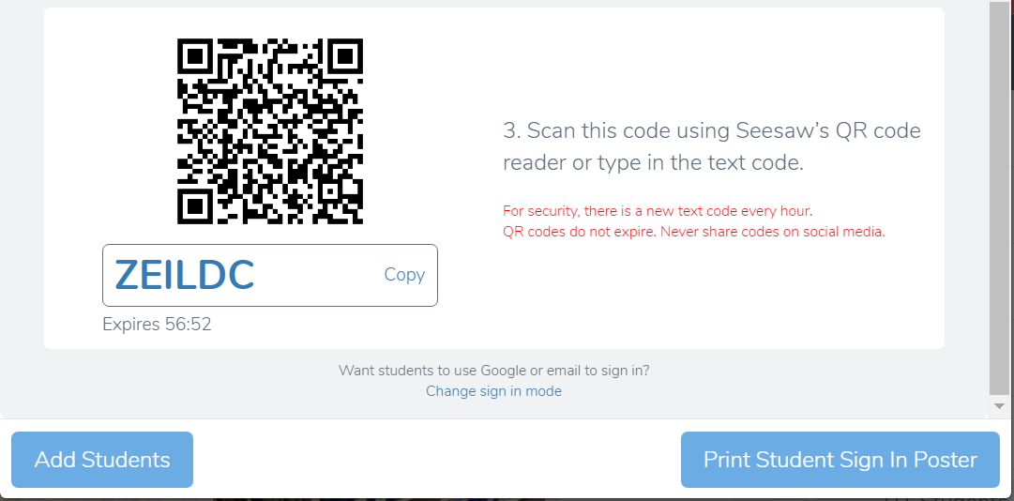
You can also use the text code at the bottom of the window to have the students log in. That might be easier to use on a Chromebook. NOTE: The text code expires after 1 hour.

